**Independent University, Bangladesh**



**Term Project**

**Course Title:** Web Application

**Course Code:** CSE 309

**Prepared for:** Sadita Ahmed

**Prepared By:**

Mohammad Arshad Hossain Ratul (1930319)

Tunisha Yanoor Bristy (1930639)

Md Nahin Islam (1930577)

**Section:** 01

**Submission Date:** 27/08/2022

Department of Computer Science & Engineering

School of Engineering, Technology & Science

Independent University, Bangladesh

Table of Contents

Section 1 4

Introduction 4

History leading to project request: 4

Problems & opportunities: 4

Problems 4

Opportunities: 5

Goals & objectives: 5

Section 2 6

Product Description 6

Product Summary: 6

Product Stakeholders: 6

Context level data flow diagram: 7

Rich picture 8

Major functionalities offered by the system 8

Functional Requirements 9

Non-functional Requirements 9

Section 4 10

Entity Relationship Diagram 10

Logical Data Flow diagram 11

Physical Data Flow diagram 12

Section 5 13

Structure English pseudo code for the system 13

Prototype the user interface 18

Diagrams

Figure 1 Context level data flow diagram 8

Figure 2 Rich Picture 9

Figure 4 Entity Relationship Diagram 11

Figure 5 Logical Data FLow diagram for the application 12

# Section 1

## Introduction

The rescuer is designed for people who will need help from a police or doctor or firefighters. It can be used in devices such as mobile phone or computer. This app will help users to ask for help in need such as in any fire emergency, medical emergency or any police emergency. In fire emergency the firefighters will be sent to the location if help is needed. In medical emergency if the suer needs medical advice, then that shall be given or of ambulance is needed that shall be sent as needed. In police emergency if the user feels he/she is in any danger and asks for help then police officers should be sent at those places to help the user.

## History leading to project request:

I decided to do this project because nowadays the rate of girls or women or men harassment has increased. The girls do not feel safe going on the road after dark and sometimes cannot ask for help if there are no people around. And road accident or fire accidents or other incidents are occurring repeatedly nowadays. This application will help the user to ask for help from police or doctor or firefighters or friends or family anytime they feel they are in danger or in emergency situations. I have seen girls feeling unsafe at road or accidents occurring but people are not coming forward to help. So, from there I got inspired to make such an application where asking for help and other services are available in one application.

## Problems & opportunities:

### Problems

|  |  |  |  |
| --- | --- | --- | --- |
|  | **Problems** | **Issues** | **Solutions** |
| P1 | Registering for the application | The confirmation code may take time | The user needs to wait and register automatically successfully |
| P2 | Sending emergency messages | If there is no internet connection | Sending messages with current location should be accessible without internet |
| P3 | Pressing help button by mistake | Sending emergency messages for help by mistake | Application can introduce a new button / option so that another message can be sent to let people know that the user is safe |
| P4 | The user gets far away from usual / local areas | Machine learning sends message to saved numbers to let them know that the user is not in his/her regular routes or areas. | The user can send an advance message to saved numbers earlier to let them know about the new route or set up in the application about the new route. |
| P5 | Phone switches off | The user cannot be tracked | The user’s last place can be tracked before the phone gets switched off by using machine learning to know the pattern of the route |

### Opportunities:

* The users can use the map and locate the police stations, hospitals and fire stations in any area and ask for help.
* The machine learning can help track the user even if the user’s phone is switched off.
* In near future, this application can help learn about self-defense and give online classes for that which will give jobs to some unemployed people.
* In future this application can help to send complains directly to government about some specific people or place where the user might be getting harassed.

## Goals & objectives:

The application can send emergency messages to the selected and saved numbers and to the nearby police station or hospitals or firefighters from a single click on the button along with their current location.

Automated calls can be sent to save numbers to ask for help if a single button is clicked from the application.

The user’s location can be seen by the selected and saved numbers added to the application if the application runs on the background of the phone.

The user can see nearby police stations, hospitals and fire stations according to their current location on the map.

Tips of safety precautions and awareness will be shared by other users on the application.

If we add machine learning to the application to track everyday route of the user then we can trace if the user suddenly changes the route or goes far away from local or regular areas.

# Section 2

## Product Description

### Product Summary:

This application will have functions that are necessary for a general user’s safety. This application will have a set of buttons which will help the user to send emergency messages to the friends added on the system, on the application and to the nearby police stations, hospitals and fire stations accordingly respectively. This application will help to send automated calls which will say that the user is in trouble and should track her number now. This application is used to help women or girls or anyone in need of danger. It can be used to track the daily route of the user and track the user’s number if in need. This application can ask for doctor’s advice and emergency ambulance if needed in emergency situations. It can also ask for help from fire stations and firefighters in an emergency of fire incidents. And provide daily life awareness routines to the general user.

### Product Stakeholders:

 The stakeholders in this application are:

* General user
* Police stations
* Police
* Hospitals
* Doctor
* Fire stations
* firefighters
* Admin

## Context level data flow diagram:

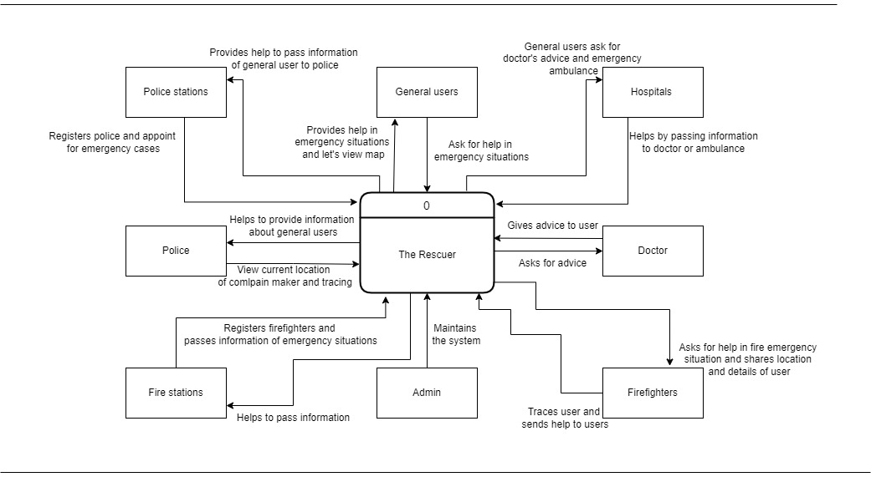

Figure Context level data flow diagram

## Rich picture

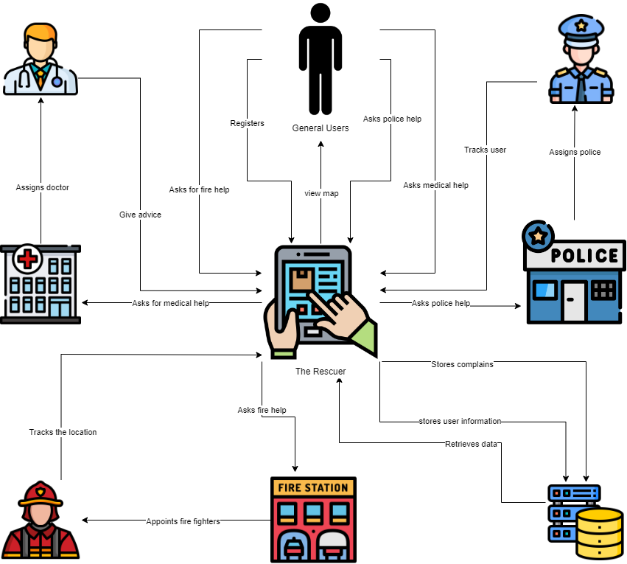

Figure Rich Picture

## Major functionalities offered by the system

* The user with access to internet can use the app
* The user can view map to see locations of police stations, hospital and fire stations
* The user can ask for help from police stations, hospital and fire stations in emergency
* The user can ask for doctor advice and call for ambulance in emergency from this app
* The user can call for police help if he/she feels is in a danger situation
* The user can call for firefighters if there is any fire emergency

## Functional Requirements

Functional requirement are the features or functions that are present in the information system that will help to clear the point of view of the system to the users and help to build the business according to requirements.

1. The users must be able to register into the system.
2. The registered users must be able to log in to the system whenever needed.
3. The users must be able to send emergency messages.
4. The users must be able to make emergency calls.
5. The users must be able to use map to see nearby current local police stations, hospitals or fire stations.
6. The users must be able to ask for awareness tips or ask for help whenever needed.
7. The friends, police stations, hospitals or fire stations must be able to receive calls or messages.
8. The user’s edited information should be updated and saved immediately.
9. The data should be saved in database correctly and update regularly.
10. Users’ personal information cannot be tampered with and must be secured tightly.
11. Admin must be able to see all the complains.
12. The users should be able to change password whenever needed.
13. The user’s confirmation code will be sent through numbers.

## Non-functional Requirements

An explanation of the system's features, qualities, and properties as well as any limitations that might set the limits of the suggested solution represent a nonfunctional requirement.

1. The user must have a good, simple and easy experience while using the system.
2. The user’s personal information should be safe and secure.
3. Admin must do the maintenance of the system regularly for a pleasant experience by the user.
4. All the users should be able to interact with each other.
5. All the purpose or functions or buttons for using the system should be fulfilled or worked accordingly.
6. To process the data, correct device or hardware should be used which must be powerful enough to load the data.

# Section 4

## Entity Relationship Diagram

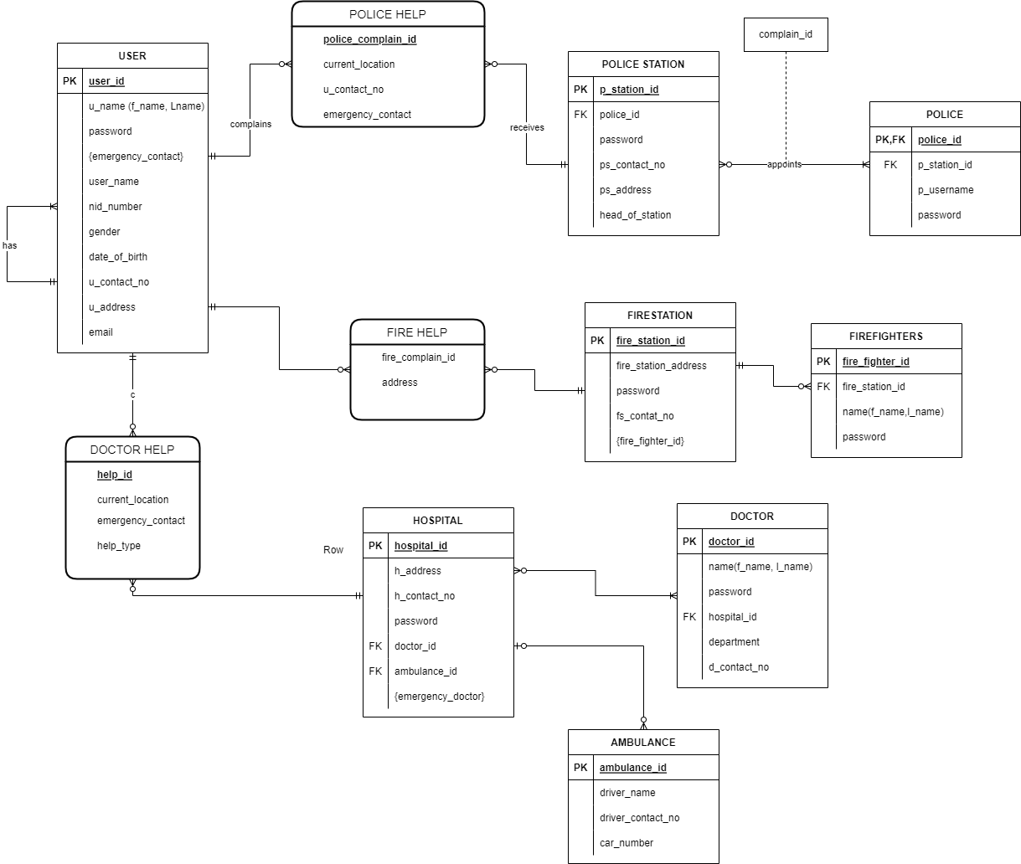

Figure Entity Relationship Diagram

## Logical Data Flow diagram

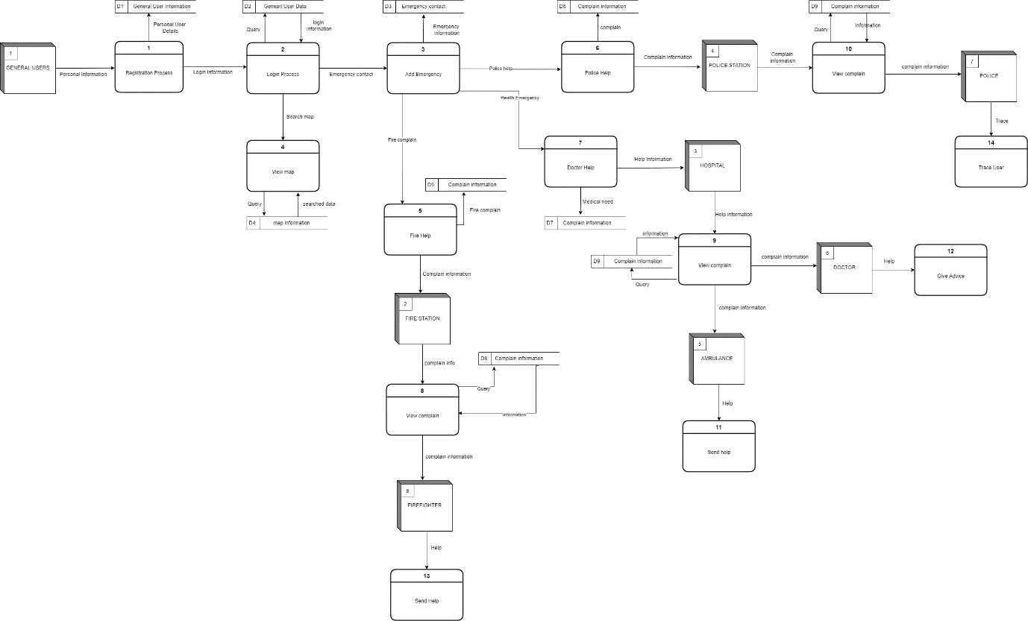

Figure Logical Data FLow diagram for the application

## Physical Data Flow diagram

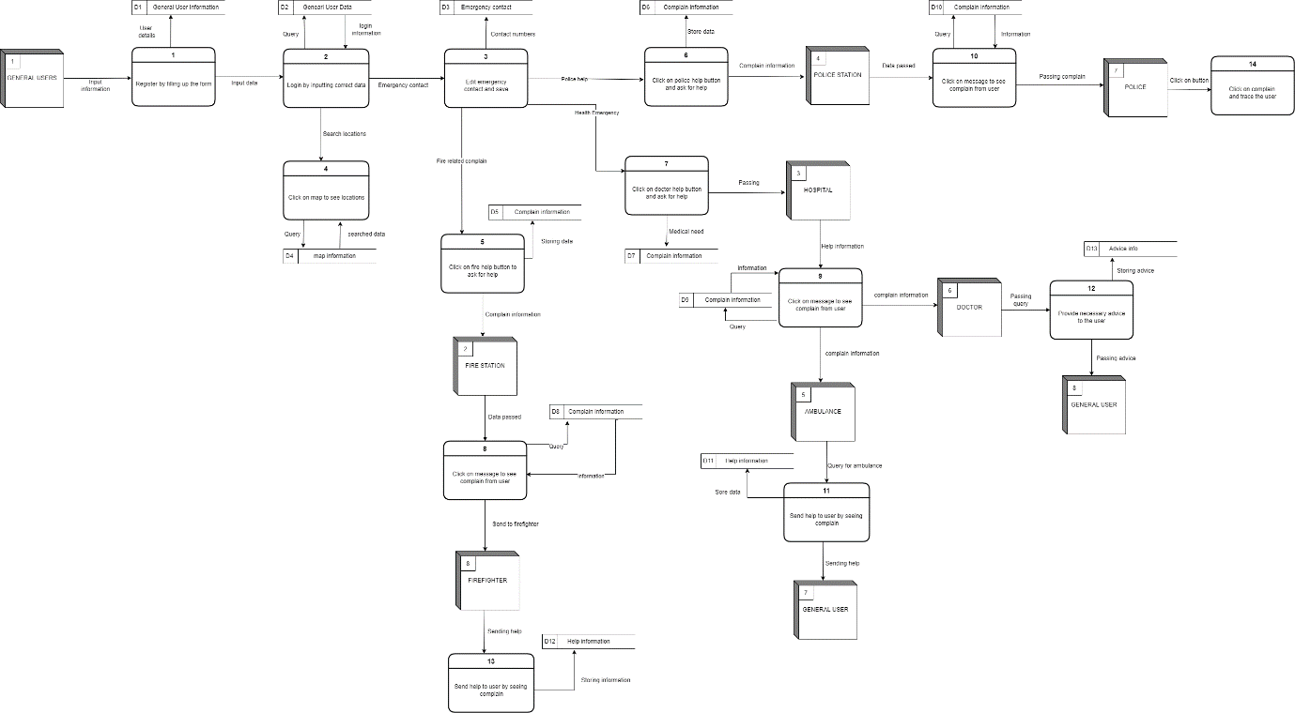

Figure 6 Physical DFD for the system

# Section 5

## Structure English pseudo code for the system

**Login**

Opens the login page

DO While staying on login page

IF Enter login information

IF Information matches to data

THEN Login done successfully

THEN Redirects to home dashboard

ELSE Show error message

ENDIF

ENDIF

ENDDO

**Police help**

Login to the system

IF Login done successfully

DO While staying logged in

DISPLAY Redirects to home dashboard

IF Press on help police button on dashboard

THEN Send information to police stations about the user

ENDIF

ENDDO

ELSE Show error

ENDIF

**Police station**

Login to the system

IF Login done successfully

DO While staying logged in

IF Registers police from the police station

THEN Those registered police are appointed with different emergency cases

DISPLAY View complains from general users

THEN Pass the shared location of user and details of user’s emergency to appointed police

ENDIF

ENDDO

ELSE Show error message

ENDIF

**POLICE**

Logs into the system

IF Login information matches to the saved data

THEN Login successfully

DO While staying logged in

IF Police station has appointed emergency case

THEN View and trace the location of the user who asked for help

THEN Police send help to the general user

ENDDO

ELSE Show message error

ENDIF

**Doctor help**

Login to the system

IF Login information matches to the saved data

DO While staying logged in

DISPLAY Redirects to home dashboard

IF Clicked on doctor help button

THEN Shows two buttons “Doctor’s advice” or “Send ambulance”

IF Clicked “Doctor’s advice”

THEN Fills a form with problems and descriptions

THEN Request is sent for doctor’s advice

ELSE Clicked “Send ambulance”

THEN Request for an ambulance

THEN Send the current location

ENDIF

ENDIF

ENDDO

ELSE Show error

ENDIF

**Fire Help**

Login to the system

IF Login information matches to the saved data

THEN Login done successfully

DO While staying logged in

DISPLAY Redirects to home dashboard

IF Press on help police button on dashboard

THEN Send information to police stations about the user

ENDIF

ENDDO

ELSE Show error

ENDIF

**Fire Station**

Login to the system

IF Login done successfully

DO While staying logged in

IF Registers firefighters from the fire station

THEN Those registered firefighters are appointed with different emergency cases

DISPLAY View complains from general users

THEN Pass the shared location of user and details of user’s emergency to appointed firefighters

ENDIF

ENDDO

ELSE Show error message

ENDIF

**Fire Fighter**

Logs into the system

IF Login information matches to the saved data

THEN Login successfully

DO While staying logged in

IF Fire station has appointed emergency case

THEN View and trace the location of the user who asked for help

THEN Firefighters send help to the general user

ENDDO

ELSE Show message error

ENDIF

**Registration**

Opens the registration page

DO While staying on registration page

ENTER Requirement information and password

IF Information new and do not with matches to other data

THEN registration done successfully

THEN Redirects to login page

ELSE Show error message

ENDIF

ENDDO

## Prototype the user interface

